Term 1 and Term 2 Student Progress Reporting for Students on an IEP
Revised June 5th, 2023
The purpose of this document is to provide guidance to classroom teachers, support teachers, vice principals and principals specific to Student Progress Reporting for students on an Individualized Education Plan. The guidance provided here is within the context of Student Inclusive Conferencing for Term 1 and Term 2 reporting.
Reporting Student Progress and IEP Planning Meetings – It is important to distinguish between reporting on student learning progress and developing or reviewing and updating a student’s IEP. While Student Inclusive Conferencing and the related written document/report may inform possible revisions to a specific student’s IEP, the conferencing time slots are not intended to review/update a student’s IEP. Of course, having a student’s IEP for reference at the conference makes sense with regards to commenting on learning progress in relation to noted IEP goals.
Where a Student is on an IEP:
- Ensure that the IEP box has been checked off at the bottom of the reporting template
  - For students where adaptations allow them to perform at grade level (e.g., speech to text, scribe, alternate ways to demonstrate learning) their assessment is based on grade level expectations
  - For students who are not yet able to work within the range of grade level expectations their assessment is based on the expectations outlined on their IEP, not on grade level expectations
- Students on an IEP with adaptations:
- Where applicable, write or type on the template: ‘Based on goals and adaptations as per IEP’
  - see sample 1 if a student has adaptations within one subject area
  - see sample 2 if a student has adaptations in several subject areas, but not all (e.g., student has adaptations in place in Language Arts, Math and Science, Socials, Career Education and ADST, but does not have adaptations in Physical).
- Where an IEP indicates a highly individualized program with very substantial program adaptations:
- See sample 3
- Type or write within the template, where applicable, “Based on goals and adaptations as per IEP”
- Do not mark an “X” within the scale. You may use anecdotal comments or leave this section blank.
- In the box on the template, ‘Areas of Strength and Areas Requiring Development/Support’
  - see sample 4 (not all adaptations listed in the IEP need to be included in the comments)
  - include comments in relation to adaptations and learning progress as appropriate.

Sample 1: Example for a student with adaptations in one subject area only (Language Arts).
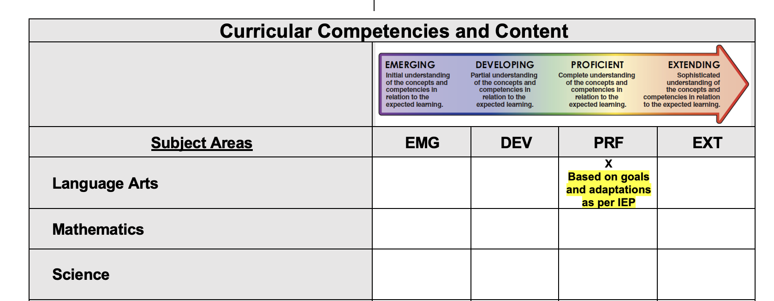

Sample 2: Example for a student with adaptations in several subject areas, but not all.
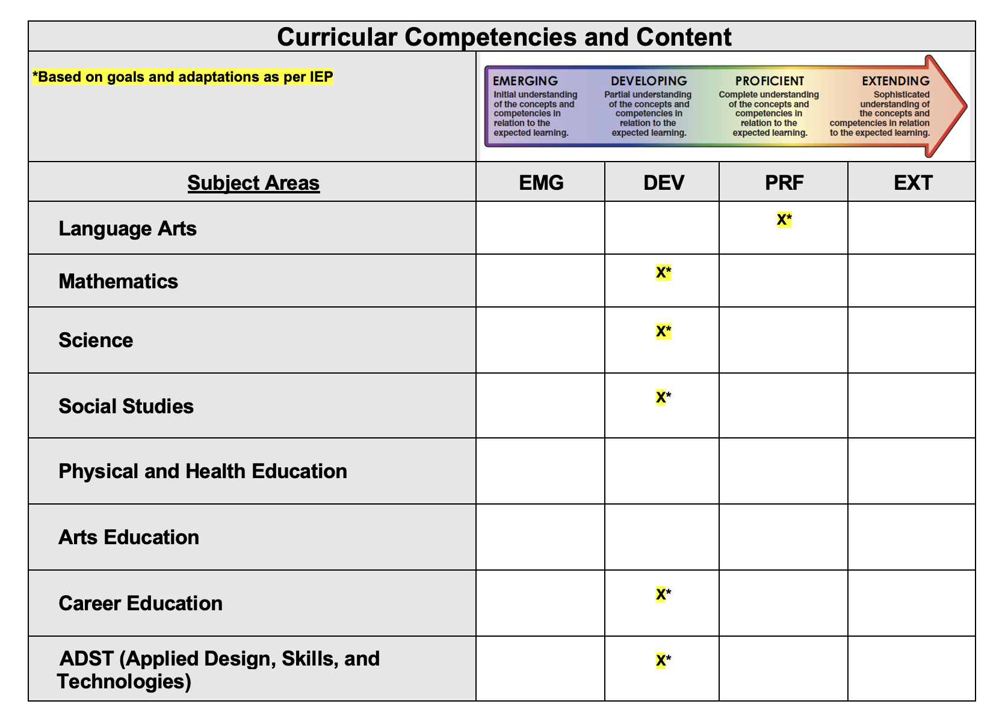

Sample 3: Examples of comments on a student on a highly adapted program 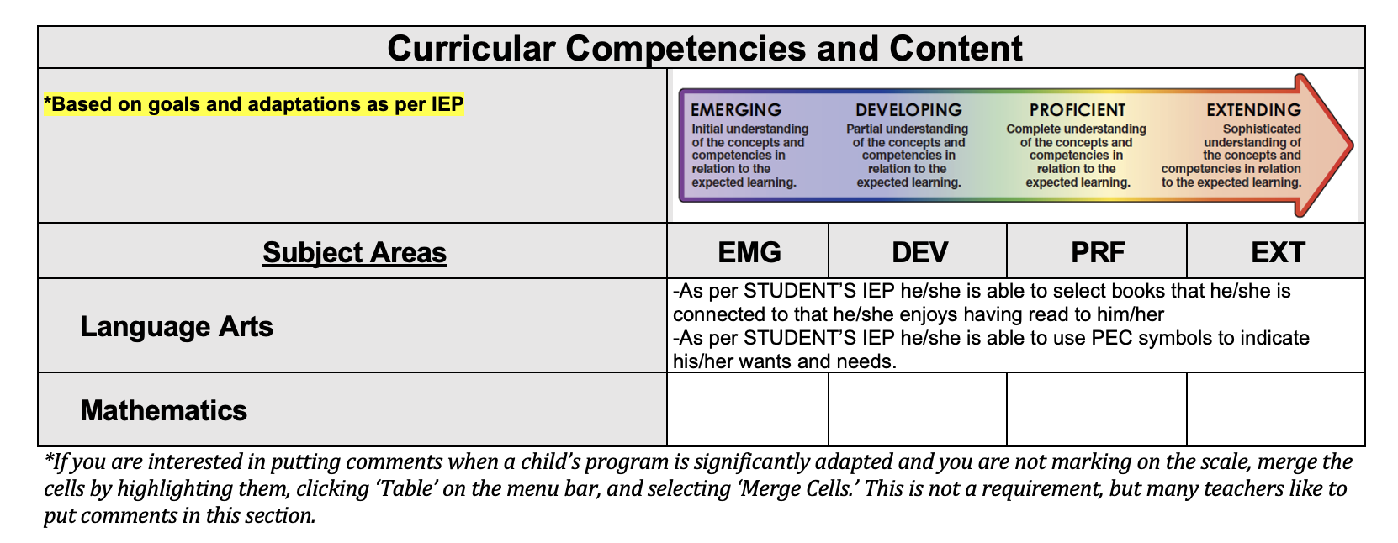
Sample 4: Examples of Adaptations and Learning Progress Comments
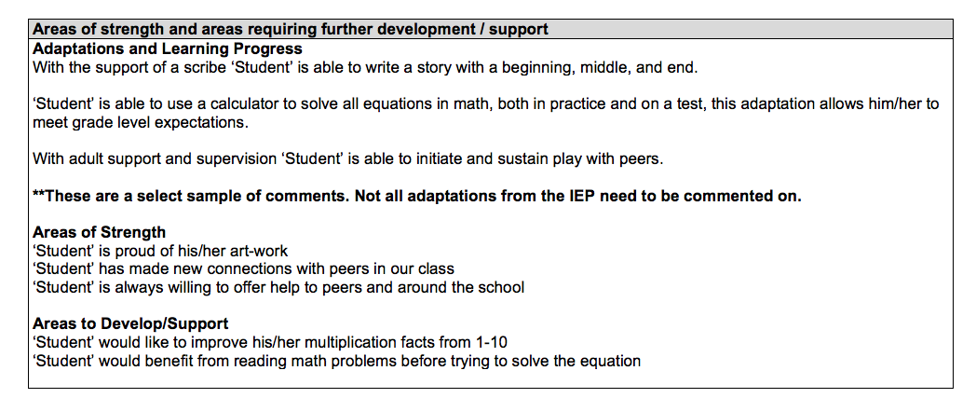
Please Note:
We understand that there may be some unique situations in our schools that do not fit within the scenarios we have outlined above. In such situations, it is suggested that classroom teachers consult and collaborate with their support teachers and school administration before proceeding.

