Student Name: |  |  | Grade: |  |  | Div.: |  |  | Teacher:
This assessment describes the student’s learning progress based on teacher’s professional judgment according to widely held expectations for this time of the year and this age group
Curricular Competencies – Language Arts
 |  |  |  | 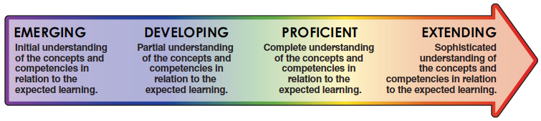
Comprehend and Connect (reading, listening, viewing) |  | - Reads at grade level
 |  | - Engages actively as a listener, a viewer and a reader to make meaning
 |  | - Uses a variety of sources and strategies to make meaning
Create and Communicate (writing, speaking, representing) |  | - Communicates ideas in writing using grade appropriate conventions of spelling, grammar and punctuation
 |  | - Plans and creates a variety of communication forms for different purposes and audiences
Curricular Competencies - Mathematics
Reasoning and Analyzing |  | - Uses reasoning to explore and make connections  - Uses mental math strategies  - Makes reasonable estimates
Understanding and Solving |  | - Uses a variety of strategies to solve math challenges  - Demonstrates and applies mathematical understanding through play, inquiry, and problem solving
Communicating and Representing |  | - Expresses mathematical thinking, (including oral, written, concrete, pictorial, symbolic and technological representations)
Connecting and Reflecting |  | - Connects and applies concepts across a variety of learning activities and in real-life situations  - Reflects on mathematical thinking

