Student Name: |  |  |  | Grade: |  |  | Div.: |  |  | Teacher:
This assessment describes the student’s learning progress based on teacher’s professional judgment according to widely held expectations for this time of the year and this age group
Curricular Competencies
French Language Arts
 |  |  |  |  | 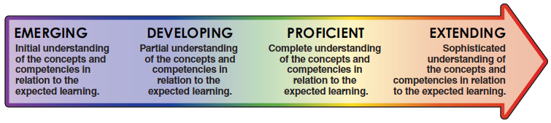
Comprehend and Connect
(reading, listening, viewing)
Comprehension |  |  | - Finds details and information, understands a variety of materials
Extension and Application |  |  | - Summarizes, synthesizes, connects, infers, predicts
Create and Communicate
(writing, speaking, representing)
Communication |  |  | - Clearly communicates ideas for a variety of purposes (descriptive, informational, narrative, persuasive), edits and revises
 |  |  | - Communicates orally in spontaneous, rehearsed or structured situations
Style and Form |  |  | - Organizes and structures ideas, uses effective vocabulary
Interactions |  |  | - Interacts with others, participates in discussions, expresses ideas and opinions
Elements |  |  | - Utilizes suitable grammar, punctuation, and spelling
Curricular Competencies
English Language Arts
Comprehend and Connect
(reading, listening, viewing)
Comprehension |  |  | - Finds details and information, understands a variety of materials
Extension and Application |  |  | - Summarizes, synthesizes, connects, infers, predicts
Create and Communicate
(writing, speaking, representing)
Communication |  |  | - Clearly communicates ideas for a variety of purposes (descriptive, informational, narrative, persuasive), edits and revises
Style and Form |  |  | - Organizes and structures ideas, uses effective vocabulary
Interactions |  |  | - Interacts with others, participates in discussions, expresses ideas and opinions
Elements |  |  | - Utilizes suitable grammar, punctuation, and spelling
Curricular Competencies - Mathematics
Reasoning and Analyzing |  | - Demonstrates mathematical strategies (i.e., estimating, mental math, logic, patterning, manipulatives, technology)
Understanding and Solving |  | - Applies appropriate strategies to solve problems and demonstrate understanding
Communicating and Representing |  | - Explains and justifies mathematical ideas. Uses mathematical vocabulary. Represents ideas in numbers, words and pictures
Connecting and Reflecting |  | - Makes connections and reflects on concepts across a variety of learning activities and/or real-life situations

