Student Name: |  |  | Grade: |  |  | Div.: |  |  | Teacher:
This assessment describes the student’s learning progress based on teacher’s professional judgment according to widely held expectations for this time of the year and this age group
Curricular Competencies – Language Arts
 |  |  |  | 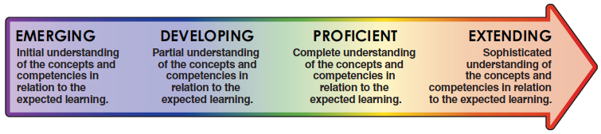
Comprehend and Connect
(reading, listening, viewing)
Comprehension |  | - Finds details and information, understands a variety of materials
Extension and Application |  | - Summarizes, synthesizes, connects, infers, predicts
Create and Communicate
(writing, speaking, representing)
Communication |  | - Clearly communicates ideas for a variety of purposes (descriptive, informational, narrative, persuasive), edits and revises
Style and Form |  | - Organizes and structures ideas, uses effective vocabulary
Interactions |  | - Interacts with others, participates in discussions, expresses ideas and opinions
Elements |  | - Utilizes suitable grammar, punctuation, and spelling

