Student Name: |  |  | Grade: |  |  | Div.: |  |  | Teacher:
This assessment describes the student’s learning progress based on teacher’s professional judgment according to widely held expectations for this time of the year and this age group
Curricular Competencies - Mathematics
 |  |  |  | 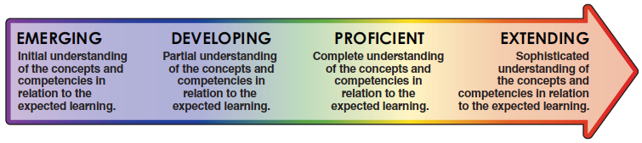
Reasoning and Analyzing |  | - Demonstrates mathematical strategies (i.e., estimating, mental math, logic, patterning, manipulatives, technology)
Understanding and Solving |  | - Applies appropriate strategies to solve problems and demonstrate understanding
Communicating and Representing |  | - Explains and justifies mathematical ideas. Uses mathematical vocabulary. Represents ideas in numbers, words and pictures
Connecting and Reflecting |  | - Makes connections and reflects on concepts across a variety of learning activities and/or real-life situations

