Student Name: |  |  |  |  | Grade: |  |  | Div.: |  |  |  | Teacher:
Communication |  |  |  | Thinking |  |  |  |  |  |  | Personal and Social
- Connects and engages with others  - Acquires, interprets and presents information  - Explains, recounts and reflects on experiences  - Collaborates with others to plan, carry out and review constructions and activities |  |  |  | - Is curious and interested in learning  - Generates questions  - Demonstrates flexibility and creativity  - Thinks beyond the obvious, innovates  - Uses knowledge and creativity to generate ideas and solve problems |  |  |  |  |  |  | - Identifies strengths and areas for growth  - Contributes to the learning community  - Identifies and manages emotions  - Solves problems in peaceful ways  - Demonstrates positive cultural identity and values differences in others  - Perseveres  - Sets goals and works towards achieving them
Self-Reflection (Student generated examples)
This assessment describes the student’s learning progress based on teacher’s professional judgement according to widely held expectations for this time of the year and this age group. Discussion regarding each curricular area will occur during the two formal student inclusive conferences.
Curricular Competencies and Content
 |  |  |  |  |  | 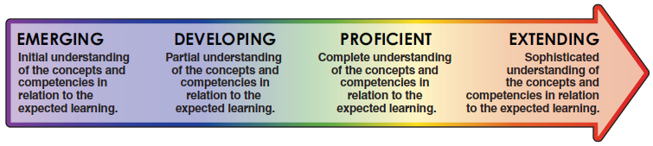
Subject Areas |  |  |  |  |  | EMG |  |  | DEV |  |  |  |  | PRF |  | EXT
French Language Arts
Mathematics
Science
Social Studies
Physical and Health Education
Arts Education
Career Education
ADST (Applied Design, Skills, and Technologies)
Areas of strength and areas requiring further development / support
Collaborative goals and next steps
English Language Learner |  |  |  |  |  |  |  |  |  |  |  |  | Individualized Education Plan
Attendance data

________________________________ ________________________________
Student’s Signature Parent or Guardian Signature for in person conferences

________________________________ ________________________________
Teacher’s Signature Principal’s signature

