Student Name: |  |  |  |  | Grade: |  |  | Div.: |  |  | Teacher:
C O R E C O M P E T E N C I E S
Communication |  |  |  |  |  | My Self-Reflection/Evidence
- Contributes to lessons, activities and discussions
- Effectively communicates, collaborates, and shares ideas
- Engages respectfully in dialogue with others
- Communicates in a variety of ways and settings
- Gives, receives, and acts on feedback
Thinking |  |  |  |  |  | My Self-Reflection/Evidence
- Demonstrates a sense of curiosity and interest
- Demonstrates flexibility and creativity
- Thinks beyond the obvious, innovates
- Uses knowledge and creativity to generate ideas and solves problems
- Finds, analyzes and evaluates information, ideas and solutions
- Makes reasoned judgments and decisions to develop personal point of view
Personal and Social |  |  |  |  |  | My Self-Reflection/Evidence
- Demonstrates respect of self and others
- Is a collaborative team member
- Is a positive role model and demonstrates leadership
- Makes healthy, safe and wise choices
- Demonstrates positive cultural identity and understands differences
- Perseveres
- Sets goals and works towards achieving them
This assessment describes the student’s learning progress based on teacher’s professional judgement according to widely held expectations for this time of the year and this age group. Discussion regarding each curricular area will occur during the two formal student inclusive conferences.
Curricular Competencies and Content
 |  |  |  |  |  | 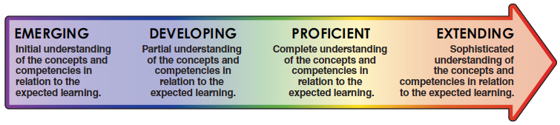
Subject Areas |  |  |  |  |  | EMG |  |  | DEV |  |  |  | PRF |  | EXT
Language Arts
Mathematics
Science
Social Studies
Physical and Health Education
Arts Education
French as a Second Language (Gr 5-7)
Career Education
ADST (Applied Design, Skills, and Technologies)
Areas of strength and areas requiring further development / support
Collaborative goals and next steps
 | English Language Learner |  |  |  |  |  |  |  |  |  |  | Individualized Education Plan
Attendance data

________________________________ ________________________________
Student’s Signature Parent or Guardian Signature for in person conferences

________________________________ ________________________________
Teacher’s Signature Principal’s signature

