Student Name: |  |  |  |  |  |  | Grade: |  |  | Div.: |  |  |  | Teacher:
C O R E C O M P E T E N C I E S
Communication |  |  |  |  |  |  |  | My Self-Reflection/Evidence
- Contributes to lessons, activities and discussions
- Effectively communicates, collaborates, and shares ideas
- Engages respectfully in dialogue with others
- Communicates in a variety of ways and settings
- Gives, receives, and acts on feedback
Thinking |  |  |  |  |  |  |  | My Self-Reflection/Evidence
- Demonstrates a sense of curiosity and interest
- Demonstrates flexibility and creativity
- Thinks beyond the obvious, innovates
- Uses knowledge and creativity to generate ideas and solves problems
- Finds, analyzes and evaluates information, ideas and solutions
- Makes reasoned judgments and decisions to develop personal point of view
Personal and Social |  |  |  |  |  |  |  | My Self-Reflection/Evidence
- Demonstrates respect of self and others
- Is a collaborative team member
- Is a positive role model and demonstrates leadership
- Makes healthy, safe and wise choices
- Demonstrates a positive cultural identity and understands differences
- Perseveres
- Sets goals and works towards achieving them
This assessment describes the student’s learning progress based on teacher’s professional judgment according to widely held expectations for this time of the year and this age group
Curricular Competencies
French Language Arts
 |  |  |  |  |  |  |  | 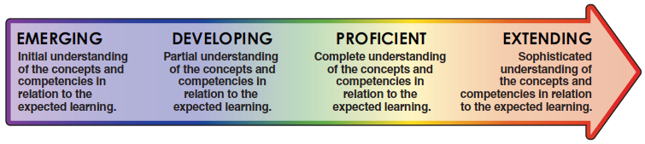
Comprehend and Connect
(reading, listening, viewing)
Comprehension |  |  | - Finds details and information, understands a variety of materials
Extension and Application |  |  | - Summarizes, synthesizes, connects, infers, predicts
Create and Communicate
(writing, speaking, representing)
Communication |  |  | - Clearly communicates ideas for a variety of purposes (descriptive, informational, narrative, persuasive), edits and revises
 |  |  | - Communicates orally in spontaneous, rehearsed or structured situations
Style and Form |  |  | - Organizes and structures ideas, uses effective vocabulary
Interactions |  |  | - Interacts with others, participates in discussions, expresses ideas and opinions
Elements |  |  | - Utilizes suitable grammar, punctuation, and spelling
Curricular Competencies
English Language Arts
Comprehend and Connect
(reading, listening, viewing)
Comprehension |  |  | - Finds details and information, understands a variety of materials
Extension and Application |  |  | - Summarizes, synthesizes, connects, infers, predicts
Create and Communicate
(writing, speaking, representing)
Communication |  |  | - Clearly communicates ideas for a variety of purposes (descriptive, informational, narrative, persuasive), edits and revises
Style and Form |  |  | - Organizes and structures ideas, uses effective vocabulary
Interactions |  |  | - Interacts with others, participates in discussions, expresses ideas and opinions
Elements |  |  | - Utilizes suitable grammar, punctuation, and spelling
Curricular Competencies - Mathematics
Reasoning and Analyzing |  | - Demonstrates mathematical strategies (i.e., estimating, mental math, logic, patterning, manipulatives, technology)
Understanding and Solving |  | - Applies appropriate strategies to solve problems and demonstrate understanding
Communicating and Representing |  | - Explains and justifies mathematical ideas. Uses mathematical vocabulary. Represents ideas in numbers, words and pictures
Connecting and Reflecting |  | - Makes connections and reflects on concepts across a variety of learning activities and/or real-life situations
Areas of strength and areas requiring further development / support
Collaborative goals and next steps
English Language Learner |  |  |  |  |  |  |  |  |  |  |  |  |  |  | Individualized Education Plan
Attendance data
Student’s Signature
Teacher’s Signature |  |  |  |  |  |  |  |  |  |  | Principal’s Signature

