Student Name: |  |  |  |  |  | Grade: |  |  | Div.: |  |  |  | Teacher:
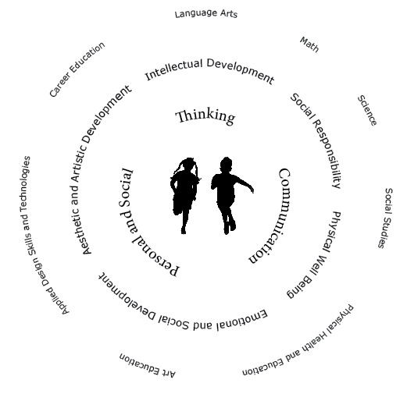
Children learn with their whole bodies, their minds, and their hearts
Communication |  |  |  | Thinking |  |  |  |  |  |  |  | Personal and Social
- Connects and engages with others  - Acquire, interpret and present information  - Explains, recount and reflects on experiences  - Collaborates with others to plan, carry out and review constructions and activities |  |  |  | - Is curious and interested in learning  - Generates questions  - Demonstrates flexibility and creativity  - Thinks beyond the obvious, innovates  - Uses knowledge and creativity to generate ideas and solve problems |  |  |  |  |  |  |  | - Identifies strengths and areas for growth  - Contributes to the learning community  - Identifies and manages emotions  - Solves problems in peaceful ways  - Positive cultural identity and values differences in others  - Perseveres  - Sets goals and works towards achieving them
Self-Reflection (Student generated examples)
Areas of Strength |  |  |  |  |  |  | Areas Requiring Support
Collaborative Goals and Next Steps
English Language Learner |  |  |  |  |  |  |  |  |  |  |  |  |  | Individualized Education Plan
Attendance data
Student’s Signature
Teacher’s Signature |  |  |  |  |  |  |  |  |  | Principal’s Signature

