Student Name: |  |  |  |  |  | Grade: |  |  | Div.: |  |  |  | Teacher:
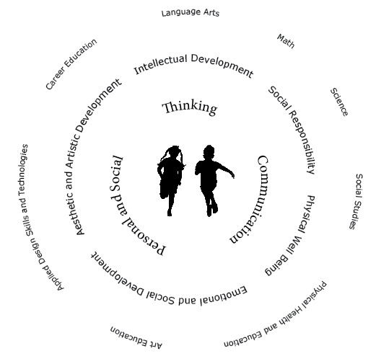
Children learn with their whole bodies, their minds, and their hearts
C O R E C O M P E T E N C I E S
Communication |  |  |  |  |  |  | My Self-Reflection/Evidence
- Connects and engages with others
- Acquire, interpret and present information
- Explains, recount and reflects on experiences
- Collaborates with others to plan, carry out and review constructions and activities

Thinking |  |  |  |  |  |  | My Self-Reflection/Evidence
- Is curious and interested in learning
- Generates questions
- Demonstrates flexibility and creativity
- Thinks beyond the obvious, innovates
- Uses knowledge and creativity to generate ideas and solve problems
Personal and Social |  |  |  |  |  |  | My Self-Reflection/Evidence
- Identifies strengths and areas for growth
- Contributes to the learning community
- Identifies and manages emotions
- Solves problems in peaceful ways
- Positive cultural identity and values differences in others
- Perseveres
- Sets goals and works towards achieving them
This assessment describes the student’s learning progress based on teacher’s professional judgment according to widely held expectations for this time of the year and this age group
Curricular Competencies – Language Arts
 |  |  |  |  |  |  | 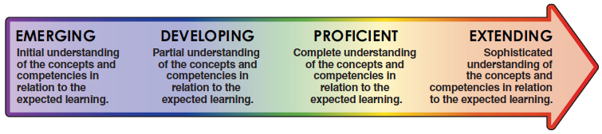
Comprehend and Connect (reading, listening, viewing) |  | - Reads at grade level
 |  | - Engages actively as a listener, a viewer and a reader to make meaning
 |  | - Uses a variety of sources and strategies to make meaning
Create and Communicate (writing, speaking, representing) |  | - Communicates ideas in writing using grade appropriate conventions of spelling, grammar and punctuation
 |  | - Plans and creates a variety of communication forms for different purposes and audiences
Curricular Competencies - Mathematics
Reasoning and Analyzing |  | - Uses reasoning to explore and make connections  - Uses mental math strategies  - Makes reasonable estimates
Understanding and Solving |  | - Uses a variety of strategies to solve math challenges  - Demonstrates and applies mathematical understanding through play, inquiry, and problem solving
Communicating and Representing |  | - Expresses mathematical thinking, (including oral, written, concrete, pictorial, symbolic and technological representations)
Connecting and Reflecting |  | - Connects and applies concepts across a variety of learning activities and in real-life situations  - Reflects on mathematical thinking
Areas to celebrate and areas to strengthen
Collaborative Goals
English Language Learner |  |  |  |  |  |  |  |  |  |  |  |  |  | Individualized Education Plan
Attendance data
Student’s Signature
Teacher’s Signature |  |  |  |  |  |  |  |  |  | Principal’s Signature

NOTE: Due to COVID-19, a parent signature will not be required for the 2021-22 school year

