Term 1 and Term 2 Student Progress Reporting for Students on an IEP
Revised January 7th, 2020
The purpose of this document is to provide guidance to classroom teachers, support teachers, vice principals and principals specific to Student Progress Reporting for students on an Individualized Education Plan. The guidance provided here is within the context of Student Inclusive Conferencing for Term 1 and Term 2 reporting.
Reporting Student Progress and IEP Planning Meetings – It is important to distinguish between reporting on student learning progress and developing or reviewing and updating a student’s IEP. While Student Inclusive Conferencing and the related written document/report may inform possible revisions to a specific student’s IEP, the conferencing time slots are not intended to review/update a student’s IEP. Of course, having a student’s IEP for reference at the conference makes sense with regards to commenting on learning progress in relation to noted IEP goals.
Where a Student is on an IEP:
- Ensure that the IEP box has been checked off at the bottom of the reporting template
  - For students where adaptations allow them to perform at grade level (e.g., speech to text, scribe, alternate ways to demonstrate learning) their assessment is based on grade level expectations
  - For students who are not yet able to work within the range of grade level expectations their assessment is based on the expectations outlined on their IEP, not on grade level expectations
- Students on an IEP with adaptations:
- Where applicable, write or type on the template: ‘Based on goals and adaptations as per IEP’
  - see sample 1 if a student has specific adaptations within a subject area, meaning that not all areas of that subject are adapted (e.g.., student orally communicates ideas instead of writing them)
  - see sample 2 if a student has global adaptations in a subject area, meaning the entire subject area is adapted (e.g., student has adaptations in place in all areas of Language Arts-reading, writing, and communication).
- In the box on the template, ‘Areas to Celebrate and Areas to Strengthen’ (primary) or ‘Areas of Strength and Areas Requiring Development/Support’ (intermediate), include comments in relation to adaptations and learning progress as appropriate.
  - see sample 4 (not all adaptations listed in the IEP need to be included in the comments)
Sample 1: Example for a student with adaptations in specific areas of Language Arts
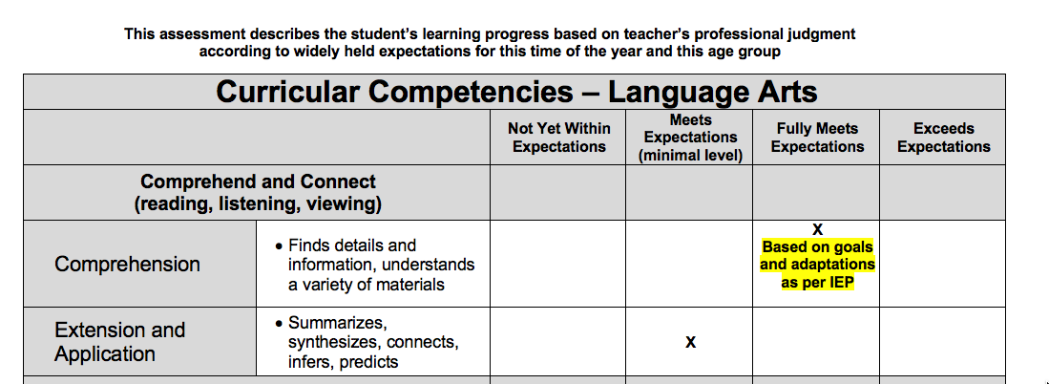
Sample 2: Example for a student with global adaptations in Language Arts
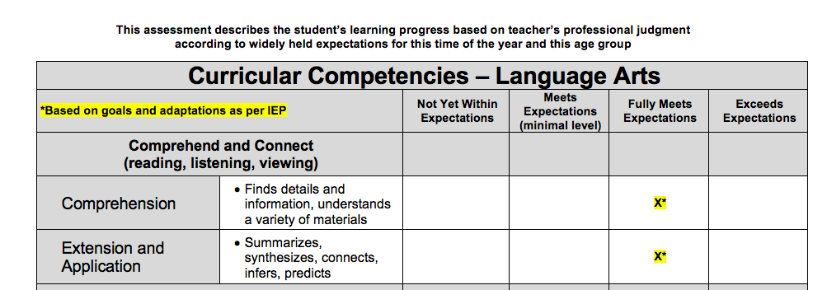
- Where an IEP indicates a highly individualized program with very substantial program adaptations:

- Type or write within the template, where applicable, “Based on goals and adaptations as per IEP”
- Do not mark an “X” within the scale. You may use anecdotal comments or leave this section blank.
  - see sample 3
- In the box on the template, ‘Areas to Celebrate and Areas to Strengthen’ (primary) or ‘Areas of Strength and Areas Requiring Development/Support’ (intermediate), include comments in relation to adaptations and learning progress as appropriate.
  - see sample 4 (not all adaptations listed in the IEP need to be included in the comments)
Sample 3: Examples of comments on a student with a highly adapted program 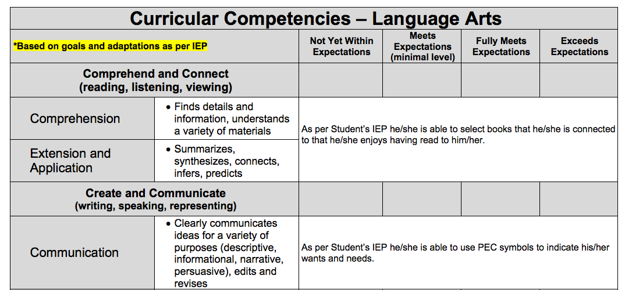
∗Ιφ ψου αρε ιντερεστεδ ιν πυττινγ χομμεντσ ωηεν α χηιλδ’σ προγραμ ισ σιγνιφιχαντλψ αδαπτεδ ανδ ψου αρε νοτ μαρκινγ ον τηε σχαλε, μεργε τηε χελλσ βψ ηιγηλιγητινγ τηεμ, χλιχκινγ ‘Ταβλε’ ον τηε μενυ βαρ ανδ σελεχτινγ ‘Μεργε Χελλσ.’ Τηισ ισ νοτ α ρεθυιρεμεντ, βυτ μανψ τεαχηερσ λικε το πυτ χομμεντσ ιν τηισ σεχτιον
Sample 4: Examples of Adaptations and Learning Progress Comments
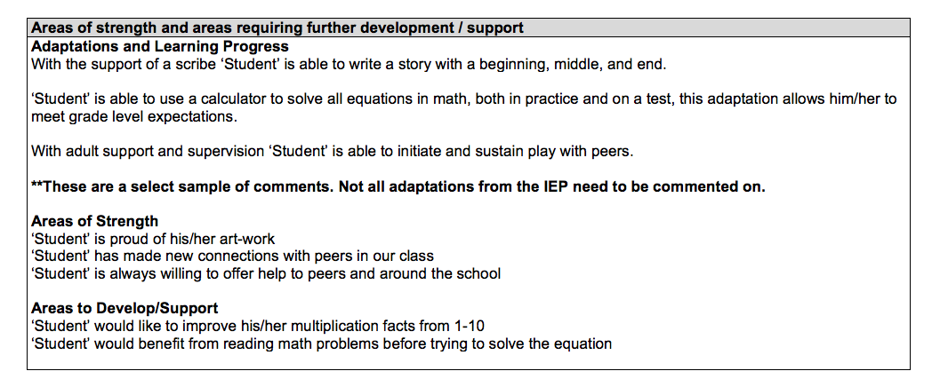

Please Note:
We understand that there may be some unique situations in our schools that do not fit within the scenarios we have outlined above. In such situations, it is suggested that classroom teachers consult and collaborate with their support teachers and school administration before proceeding.

