The circular graphic:

What is the rationale for including the graphic?
- Descriptive feedback is the factor that makes the most difference to learning.
- Our conferences are a celebration of learning, but they are also a form of assessment for learning.
- The conferences are another way to engage children in their own learning.
- Makes learning visible

The central idea behind this graphic is to serve as a representation of the learning experiences and competencies that surround the WHOLE CHILD at school.

We may be more familiar and comfortable with this mapping of “whole child development.” Where are these 4 areas found on the circular graphic?

So you might start with something like this…

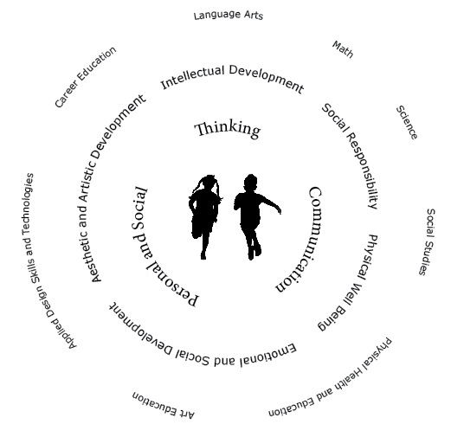
cognitive
language
physical
social emotional
But soon you find more connections …. and these are just the beginning …

The “take-away” is to consider how the aspects of curricular content, curricular competencies and core competencies are inextricably linked.
We are not teaching “subjects,” we are creating opportunities for the development of the whole child.

So, let’s get specific. How does this translate to a conversation during a conference? What kinds of things do we talk about? Do we have to mention everything?

Begin with the child.
- What are strengths that immediately stand out?
- Where do the strengths fall on the graphic?
- How are do these strengths impact other areas on the graphic?
- What items in the portfolio support your comments?
- What do you see as areas in progress?
- Is there an area for growth that can be mentioned here?

In the curriculum documents, you will find a vast amount of profiles, descriptors and “I can” statements. I highly recommend you spend time looking through these, in context, but I would like to give you a “jumping off point.” I appreciate the complex time consuming aspects of our role as teachers.

To get started, choose a few that resonate with what you are doing in your classroom.
Your statements might start with, e.g., “In our classroom, we have been working on listening to each other and making contributions during class discussions and small group work. I notice that … often mentions things that others have said and then adds his own ideas. This shows… that s/he is listening and making connections with classmates and their ideas.

During the conference, or before, you might circle or highlight “communication” as you give an example what you see the child doing.

Do you have to write on the graphic, no…
You have the option to use the text box before the conference to jot a few reminder notes to yourself…

e.g., The first thing that comes to mind when I think of ____ as a learner…

What really stands out about ____ is _____________________

