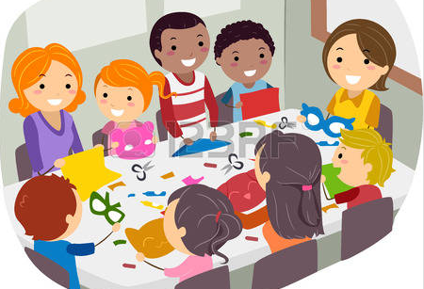

**I can**

**participate**

**in classroom and group activities**

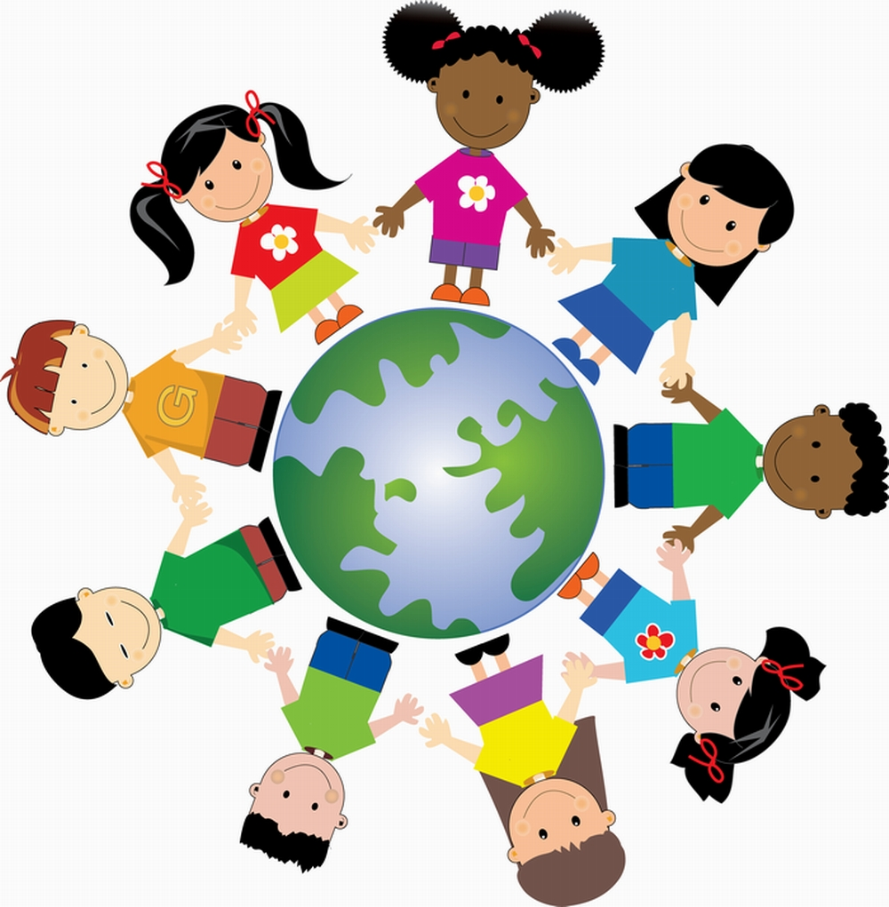

**I can include**

**others**



**I can use WITS to solve problems**

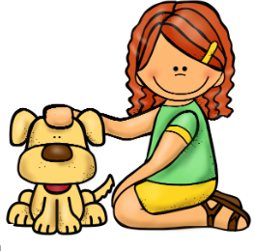

**I am kind to others**

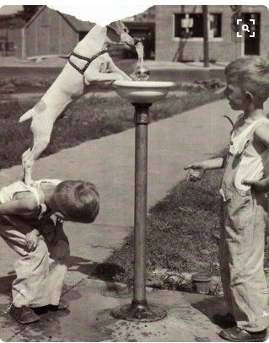

**I can help others**



**I can share what is important to me**



**I can say what I am good at and what I need to work on**



**I can recognize my feelings**



**I can persevere when something is hard to do**



**I can be responsible for my learning and behavior**