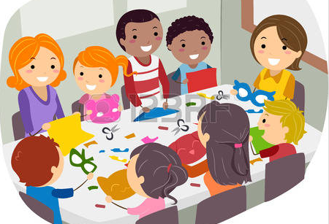

**I can participate in classroom**

**and group activities**

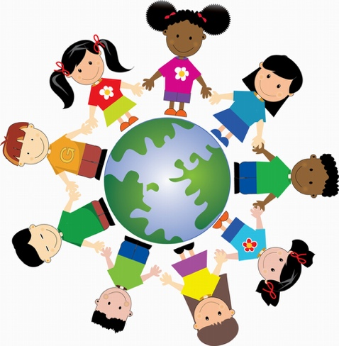

**I can include others**



**I can use WITS to solve problems**

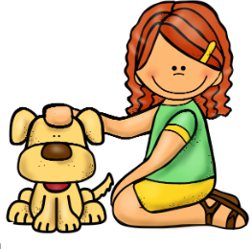

**I am kind to others**

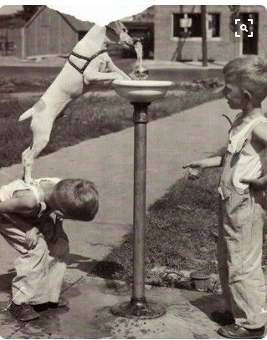

**I can help others**



**I can recognize my feeling**



**I can be responsible for my learning**

**and behavior**



**I can share what is important to me**



**I can say what I am good at and what I need to work on**



**I can perservere when something**

**is hard to do**