

**I can**

**ask and answer questions**

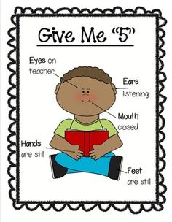

**I am an**

**active listener**



**I can work with others**



**I can show my learning**