

**I can ask and answer questions**

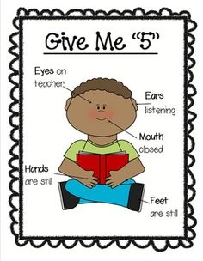

**I am an active listener**



**I can show my learning**



**I can work with others**



**I can ask and answer questions**



**I am an active listener**



**I can show my learning**



**I can work with others**